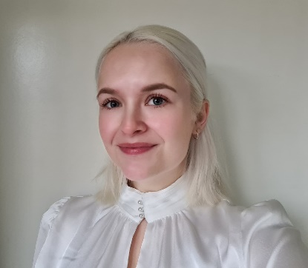

My experience with Dessa and soft skills

My name is Maaike, I’m 23 years old and I’m a student at Friesland College.
I’m an intern at MentorProgramma Friesland. I’ve been asked to participate in the short pilot for the Dessa project.
Before my internship at MentorProgramma Friesland I hadn’t heard of soft skills, I didn’t know what soft skills were. At school you learn a lot of things, but most of the skills you learn are hard skills, skills that are related to your field of work.
I really enjoyed learning about soft skills and thinking about where I stand in the development of certain soft skills. I learned a lot about myself and my strengths and weaknesses. My goal in life has changed ever since I started working on my soft skills. I now have a different perspective on my future than I had before and I plan on pursuing this newfound dream.
I feel like I’m stronger as a person now that I know which soft skills I possess and which ones need some work. I feel more confident in and less scared of starting new things.
I believe everyone could benefit from developing their soft skills, no matter how old or young you are. They are versatile skills that can be used in every aspect of life. I hope the development of soft skills during apprenticeships will be mandatory for all interns, because we all benefit from more confident and self-aware members of our society.

